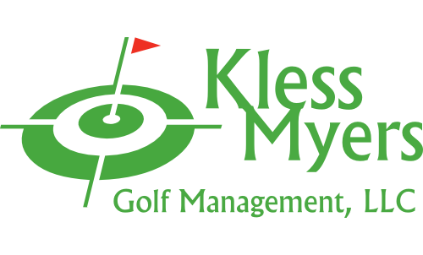

Thank you for considering Lyndon Golf Course for your event. The golf operations are professionally managed by Kless Myers Golf Management, LLC. Please complete and return the attached contract with your deposit.
DEPOSIT: The deposit will be applied to the cost of your outing. Upon receipt of the signed agreement and deposit, the starting times will be reserved for your group. Your required deposit is based on your reservation size (minimum outing size 12 players). The deposit is $5 per player up to a maximum deposit of $100 for groups of 20 or more.
GUARANTEE: Seven days in advance of your outing, you are required to confirm the guaranteed count of your event. Any additions to the number of players should be done as soon as possible and will be subject to the availability of tee times.
PAYMENT: The remaining balance is due on the day of the event and must be submitted in one transaction. Please collect any money due from individual players prior to making this payment. You are responsible for the guaranteed number of players.
CANCELLATION: The event can be cancelled without penalty a minimum of 30 days in advance of the outing date. You will receive a full refund of your deposit. Cancellation at least 20 days prior to your date will receive a 50% refund of the deposit. Cancellation within 10 days or less, deposit will be forfeited. Rain or inclement conditions are not grounds for cancellation. If the course is open the group is expected to play. If the weather is sever/dangerous or the course is deemed unplayable by golf course staff, an alternative date can be scheduled or a refund issued for unused, non-perishable services and goods.
RAIN CHECK POLICY: Completion of 14 to 18 holes, no rain check will be issued. Completion of 5 to 12 holes, 9 hole rain check will be issued. Completion of 4 or less holes, 18 hole rain check will be issued.

Thank you
initial

initial

initial

initial

initial

initial

initial

initial
initial
Terms and Conditions
- Payment. A $5 per player deposit is required to secure the date of your event up to a maximum deposit of $100. Full payment is required the day of the event. The primary tournament contact is responsible for collecting greens fees, cart fees and food service fees. The event will not be allowed to tee off unless full payment is made prior to scheduled starting time.

- Rosters. All reservations are required to complete the Tournament Pairing and Information Form outlining the details of the event. This form must be submitted at least 48 hours prior to the event.

- Rules. Players must adhere to all posted rules and directions from golf course staff in regards to proper golf etiquette and responsibility for damages to the golf course or golf carts.

- Outside Food & Beverages. It is strictly forbidden, as a group or individual, to bring any outside food or beverages onto the premises. Golf management reserves the right to dismiss anyone violating this policy and fine the organization $50 per occurrence. All food and beverage must be purchased through the golf course concession department.

- Event Confirmation. A confirmation of players/teams and menu is required 7 days prior to the event. The guaranteed count cannot be reduced, but can be increased as space permits. You will be charged on the guaranteed count or the actual count, whichever is greater.

- Property. All property brought in by the tournament contact person and/or guests must be removed at the conclusion of the event. Golf management is not responsible for any loss or damage to your property during the event.

- Cancellation. The event can be cancelled without penalty a minimum of 30 days in advance of the outing date. You will receive a full refund of your deposit. Cancellation at least 20 days prior to your date will receive a 50% refund of the deposit. Cancellation within 10 days or less, deposit will be forfeited. Rain or inclement conditions are not grounds for cancellation. If the course is open the group is expected to play. If the weather is sever/dangerous or the course is deemed unplayable by golf course staff, an alternative date can be scheduled or a refund issued for unused, non-perishable services and goods.

- Indemnification. To the extent permitted by law, you agree to protect, indemnify, defend and hold harmless Kless Myers Golf Management, LLC and and their respective employees against all claims, losses or damages to persons or property, governmental charges or fines and costs, including reasonable attorney fees, arising out of or connected to your function.

- Amendments/Changes. Any amendments or changes to the arrangements described in this contract must be made in writing, signed by both parties.

Tournament Contract
Group Name Event Date

Primary Contact(s)
Phone E-mail
Address City State Zip

Expected Player Count Guaranteed Count Due Price per Player w/cart Deposit Amt
Type of Start: Shotgun* Modified Start** Tee Times From To
*Shotgun starts at 8 am or 1 pm with a 72 Player minimum
**Modified starts available to groups of 20 or more.
Additional Set up Details

Expected Player Count Guaranteed Count Due Price before Tax & Gratuity
Menu Selection

Additional Set up Details

Beverage Service Instructions

Signed Date

Signature
Food and Beverage Service
Tournament Information
Contact Information

